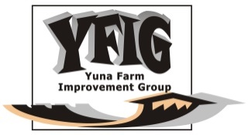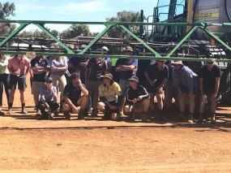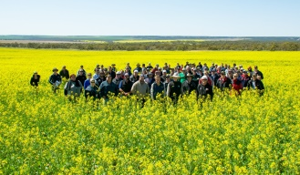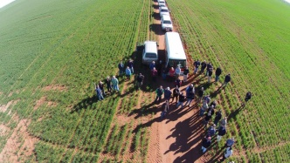
Yuna Farm Improvement Group
MEMBERSHIP APPLICATION FORM
Trading Name (Farm Business & Corporate Membership only)
Individual Name
(Individual Membership only)
Business Contact Person/s | Name #1 |  | Name #2
Mobile Number/s

Email

Address

Email: yuna.fig@gmail.com Website www.yfig.org.au
I agree with the purpose of Yuna Farm Improvement Group
Signature ____________________________ Date__________________
CLASS OF MEMBERSHIP
FARM BUSINESS MEMBERSHIP - $150 (Supports the objects or purposes of the Association, full voting rights, invitation to all events, information via email circular, access to equipment locally – weigh trailer, cool room, pizza oven, bus, soil sampler, marquee, pH tester, PA, biosecurity trailer)
INDIVIDUAL MEMBERSHIP - $50 (Supports the objects or purposes of the Association, full voting rights)
CORPORATE MEMBERSHIP - $150 (A business associated with the Ag industry, Supports the objects or purposes of the Association, invitation to all events, information via email circular)
YFIG Personal Information Privacy Statement: All information collected in this form will solely be used to contact YFIG members for YFIG purposes and this information will not be shared with third parties
YFIG are a not for profit local grower group with no employed staff and a positive outlook on agriculture. We are an incorporated association under the Associations Incorporations Act 2015 with the following purpose:
  - To provide members and local growers with opportunity to visit and receive results from trials i.e. Field days, crop establishment walks etc.
  - To liaise with appropriate organisations to organise trial programs for the Yuna area.
  - To organise local farm updates and seminars relating to local farming issues.
  - To fundraise to finance the group and assist other local community organisations through either growing a crop or any other means of fundraising.

YUNA FARM IMPROVEMENT GROUP INC
2021 Membership Application

